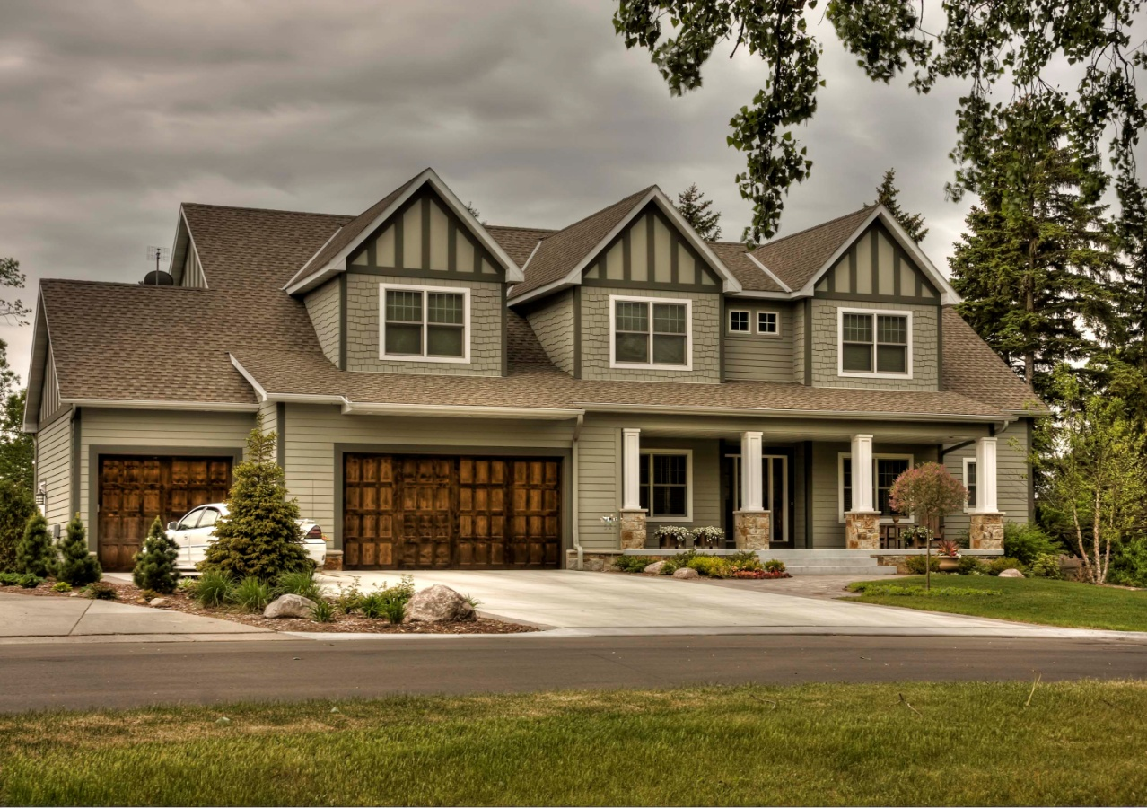
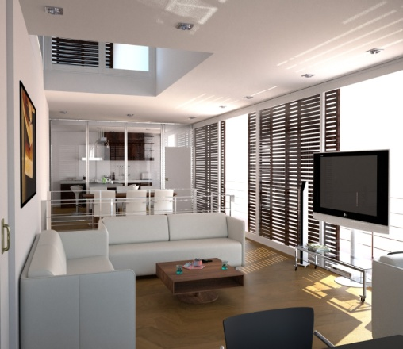
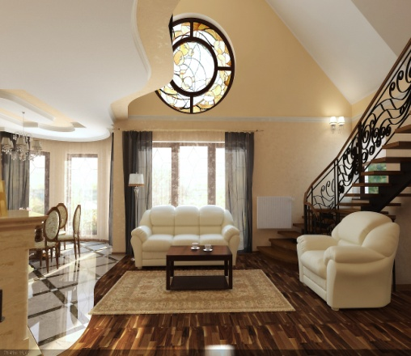
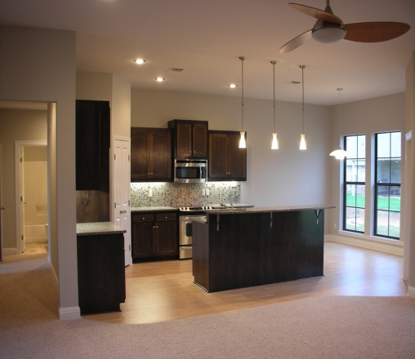
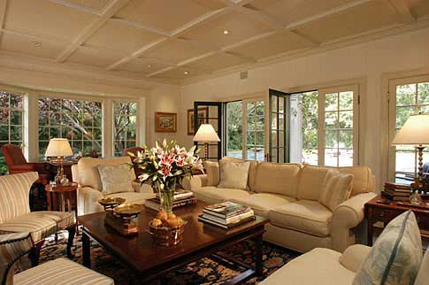

2218 Blake Street, Berkeley
Currently 2 or 3 units*. If used as a single family home, could have 5 bedrooms and 3 baths. Check with the City of Berkeley about conversion to single family use. Large, south facing, yard, beautiful period details, close to the University, Elmwood and BART. Disclosures available ONLY through your agent per MLS. Offers May 28th – contact your agent for MLS instructions. Secure financing must be submitted with offer.
More info at www.hloom.com
Offered at $395,000
Jennifer Taylor
REALTOR
515.123.4567 cell / 555.123.4567 / email here
Website #1 here / Website #2 here
1191 Ethels Lane, Tampa, FL 3310

Copyright information - Please read

© This Free Flyer Template is the copyright of Hloom.com. You can download and modify this template for your own personal use to create a flyer for yourself, or for someone else. You can (and should!) remove this copyright notice before customizing your flyer.

You may not distribute or resell this template, or its derivatives, and you may not make it available on other websites without our prior permission. All sharing of this template must be done using a link to http://www.hloom.com/flyers/.

For any questions relating to the use of this template please email us - info@hloom.com

