Lauren Jenkins
Graphic Designer

info@hloom.com
123 Park Avenue,
Michigan MI 60689
Highly creative individual with the ability to deliver high-quality designs that both follow and encompass brand content quality guidelines plus adding years of professional experience as a Marketer and Designer for websites.
WORK EXPERIENCE |  | Senior Designer  Creative Bee (2011 – present)  - Liaised with clients to understand briefs and direction.  - Created conceptual responses, graphics, and process flow diagrams.  - Worked with client services and created rich media solutions.  Assistant Designer  Gravity Designs (2005 – 2011)  - Executed all stages of design through product enhancements.  - Worked closely with various members to prepare future sets.  - Mentored new members and adhered to design strategies and guidelines.
EDUCATION |  | Bachelor of Art  Green Elephant Arts (1999 – 2001)  Cool Design Training  Blue Bee Art (1989)
SKILLS |  | 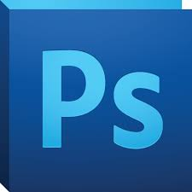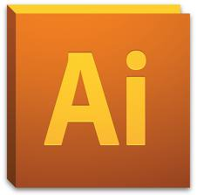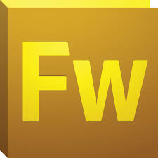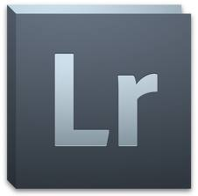

Copyright information - Please read

© This Free Resume Template is the copyright of Hloom.com. You can download and modify this template for your own personal use to create a resume for yourself, or for someone else. You can (and should!) remove this copyright notice (click here to see how) before sending your resume to potential employers.

You may not distribute or resell this template, or its derivatives, and you may not make it available on other websites without our prior permission. All sharing of this template must be done using a link to http://www.hloom.com/resumes/. For any questions relating to the use of this template please email us - info@hloom.com

