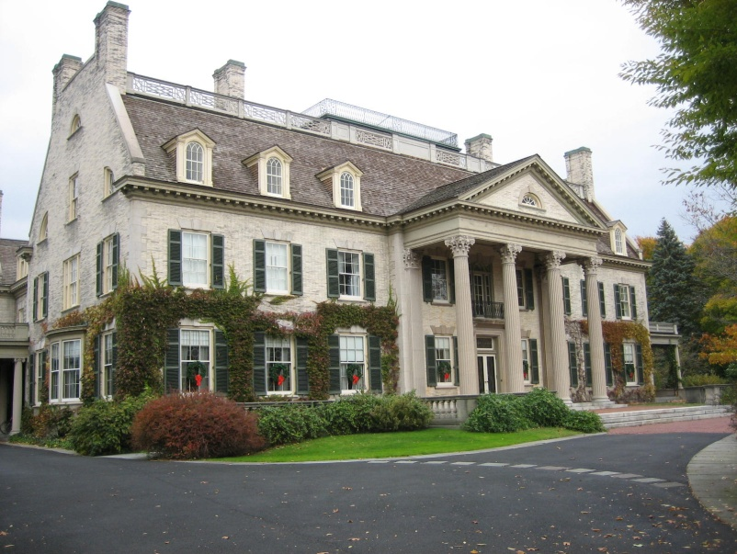
$449,900
4432 Parrish Avenue

Charming, spacious, light-filled Victorian farmhouse, circa 1900, with wrap-around porch, second floor balcony, master bedroom and adjoining sitting room. This elegant home is tastefully renovated to complement its original features. This includes front and back stair-cases and stunning stained glass. This also offers a two car detached garage, which works well as a fine studio. Property has newer roof and HVAC, gleaming hardwood floors, remodeled kitchen and bath.

The House is being presented by
Terry A. Grasso

Phone: (515) 123-4567
Fax: (515) 123-4568
www.hloom.com
- Square Feet – 2,862
- Lot Size – 0.25 acre
- Bedrooms – 5
- Baths – 2 full
- Hardwood Floors
- Front Yard
- Small balcony
- Wraparound porch
- Garage
- Taxes - $4,827
Magnificent
Victorian Palace

Copyright information - Please read

© This Free Flyer Template is the copyright of Hloom.com. You can download and modify this template for your own personal use to create a flyer for yourself, or for someone else. You can (and should!) remove this copyright notice before customizing your flyer.

You may not distribute or resell this template, or its derivatives, and you may not make it available on other websites without our prior permission. All sharing of this template must be done using a link to http://www.hloom.com/flyers/.

For any questions relating to the use of this template please email us - info@hloom.com

