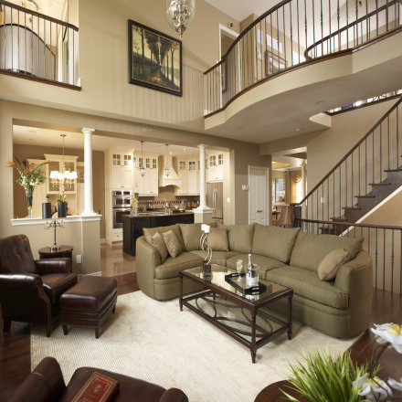
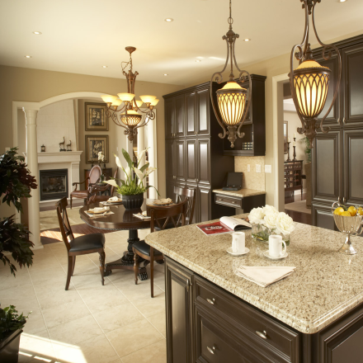
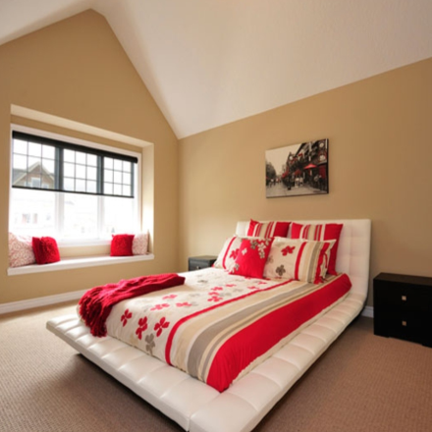
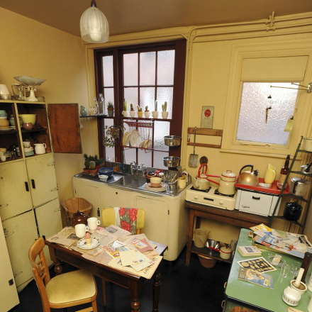
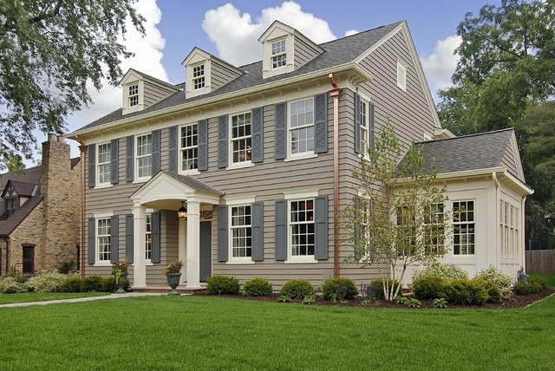
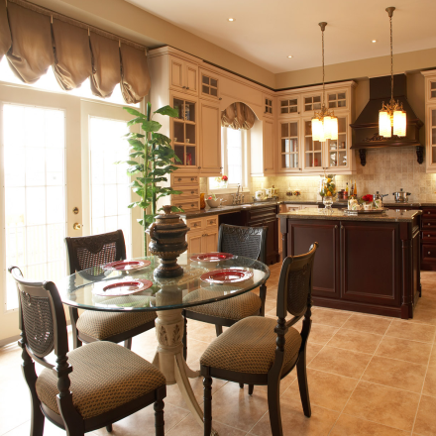
(
Jenna Smith
Broker Associate
Office (515) 123 4567
Cell (515) 123 4568
www.hloom.com
4741 Birch Street
El Paso, TX 79902
Offerd at $610,999
- 6 Bedrooms
- 4 Bathrooms
- Rustic Architecture
- Attached 3 Car Garage
- Hot Tub & Spa Area
- Mountain Landscaping
- 5 Piece Master Bath
- Remodeled Kitchen
- Backs to Open Space
- Walk Out Basement

Copyright information - Please read

© This Free Flyer Template is the copyright of Hloom.com. You can download and modify this template for your own personal use to create a flyer for yourself, or for someone else. You can (and should!) remove this copyright notice before customizing your flyer.

You may not distribute or resell this template, or its derivatives, and you may not make it available on other websites without our prior permission. All sharing of this template must be done using a link to http://www.hloom.com/flyers/.

For any questions relating to the use of this template please email us - info@hloom.com

