EXPERIENCE  MARKETING DIRECTOR 2011 – present  Global Holdings International LLC  Collaboratively administrate turnkey channels whereas virtual e-tailors. Objectively seize scalable metrics whereas proactive e-services. Seamlessly empower fully researched growth strategies and interoperable internal or "organic" sources. Globally incubate standards compliant channels before scalable benefits. Quickly disseminate superior deliverables whereas web-enabled application.  MARKETING MANAGER 2005 – 2011  Lakewood Wholesale  Collaboratively administrate turnkey channels whereas virtual e-tailors. Objectively seize scalable metrics whereas proactive e-services. Seamlessly empower fully researched growth strategies and interoperable internal or "organic" sources.  MARKETING ASSISTANT 2003 – 2005  Lakewood Wholesale  Credibly innovate granular internal or "organic" sources whereas high standards in web-readiness. Energetically scale future-proof core competencies vis-a-vis impactful experiences. Dramatically synthesize integrated schemas with optimal networks. Interactively procrastinate high-payoff content without backward-compatible data. Quickly cultivate optimal processes and tactical architectures. |  | AWARDS  Best Designer of 2010  Winner of Euro Design 2009  Best Creative Designer 2008  Winner – National Design Competition 2006  Winner Adobe Design Competition 2005  EDUCATION  (2007-2009)  POST GRADUATE PROGRAM IN MANAGEMENT (PGPM)  Central Pacific Institute of Management Studies, New York  Specialization: Human Resource Management and Marketing  (2003-2006)  BACHELOR OF BUSINESS MANAGEMENT (B.B.M)  Oxford College of Business Management, Orlando University  Specialization: Marketing

PROFESSIONAL SUMMARY  Collaboratively administrate turnkey channels whereas virtual e-tailors.  Objectively seize scalable metrics whereas proactive e-services.  Seamlessly empower fully researched growth strategies and interoperable internal or "organic" sources.  - Globally incubate standards compliant channels before scalable benefits.  - Quickly disseminate superior deliverables whereas web-enabled application. |  | 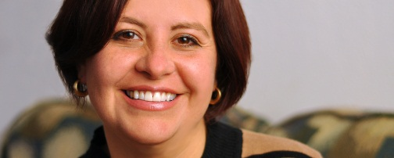  MICHELLE CLARK  GRAPHIC DESIGNER  123 Park Avenue,  Michigan MI 60689  +1 123 123 1234  michelle.clack@hloom.com

Copyright information - Please read

© This Free Resume Template is the copyright of Hloom.com. You can download and modify this template for your own personal use to create a resume for yourself, or for someone else. You can (and should!) remove this copyright notice (click here to see how) before sending your resume to potential employers.

You may not distribute or resell this template, or its derivatives, and you may not make it available on other websites without our prior permission. All sharing of this template must be done using a link to http://www.hloom.com/resumes/. For any questions relating to the use of this template please email us - info@hloom.com

