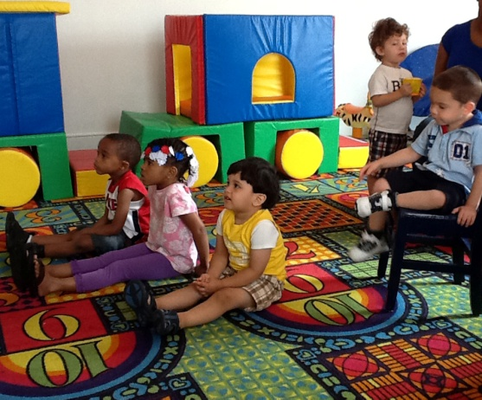
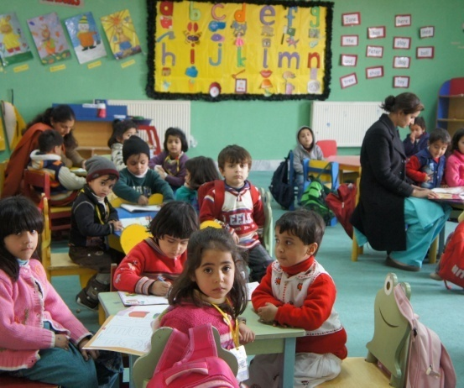

3503 Fairway Drive, Vacaville, CA 95688 – (123) 456 7899
www.hloom.com – info@hloom.com

We believe that all children are very unique and special in their own way. We promote social, intellectual, physical, and emotional development.
Circle Time - Read Aloud - Art and Craft - Gross Motor Skills
Fine Motor Skills - Cooperative Learning - Dramatic Play

BELLS & BUBBLES CHILDCARE

Copyright information - Please read

© This Free Flyer Template is the copyright of Hloom.com. You can download and modify this template for your own personal use to create a flyer for yourself, or for someone else. You can (and should!) remove this copyright notice before customizing your flyer.

You may not distribute or resell this template, or its derivatives, and you may not make it available on other websites without our prior permission. All sharing of this template must be done using a link to http://www.hloom.com/flyers/.

For any questions relating to the use of this template please email us - info@hloom.com

