[](https://www.myperfectresume.com/membership/RegisterGuestUser.aspx?wizard=true&productid=17&utm_source=hloom-com&utm_medium=referral&utm_campaign=word-template)  
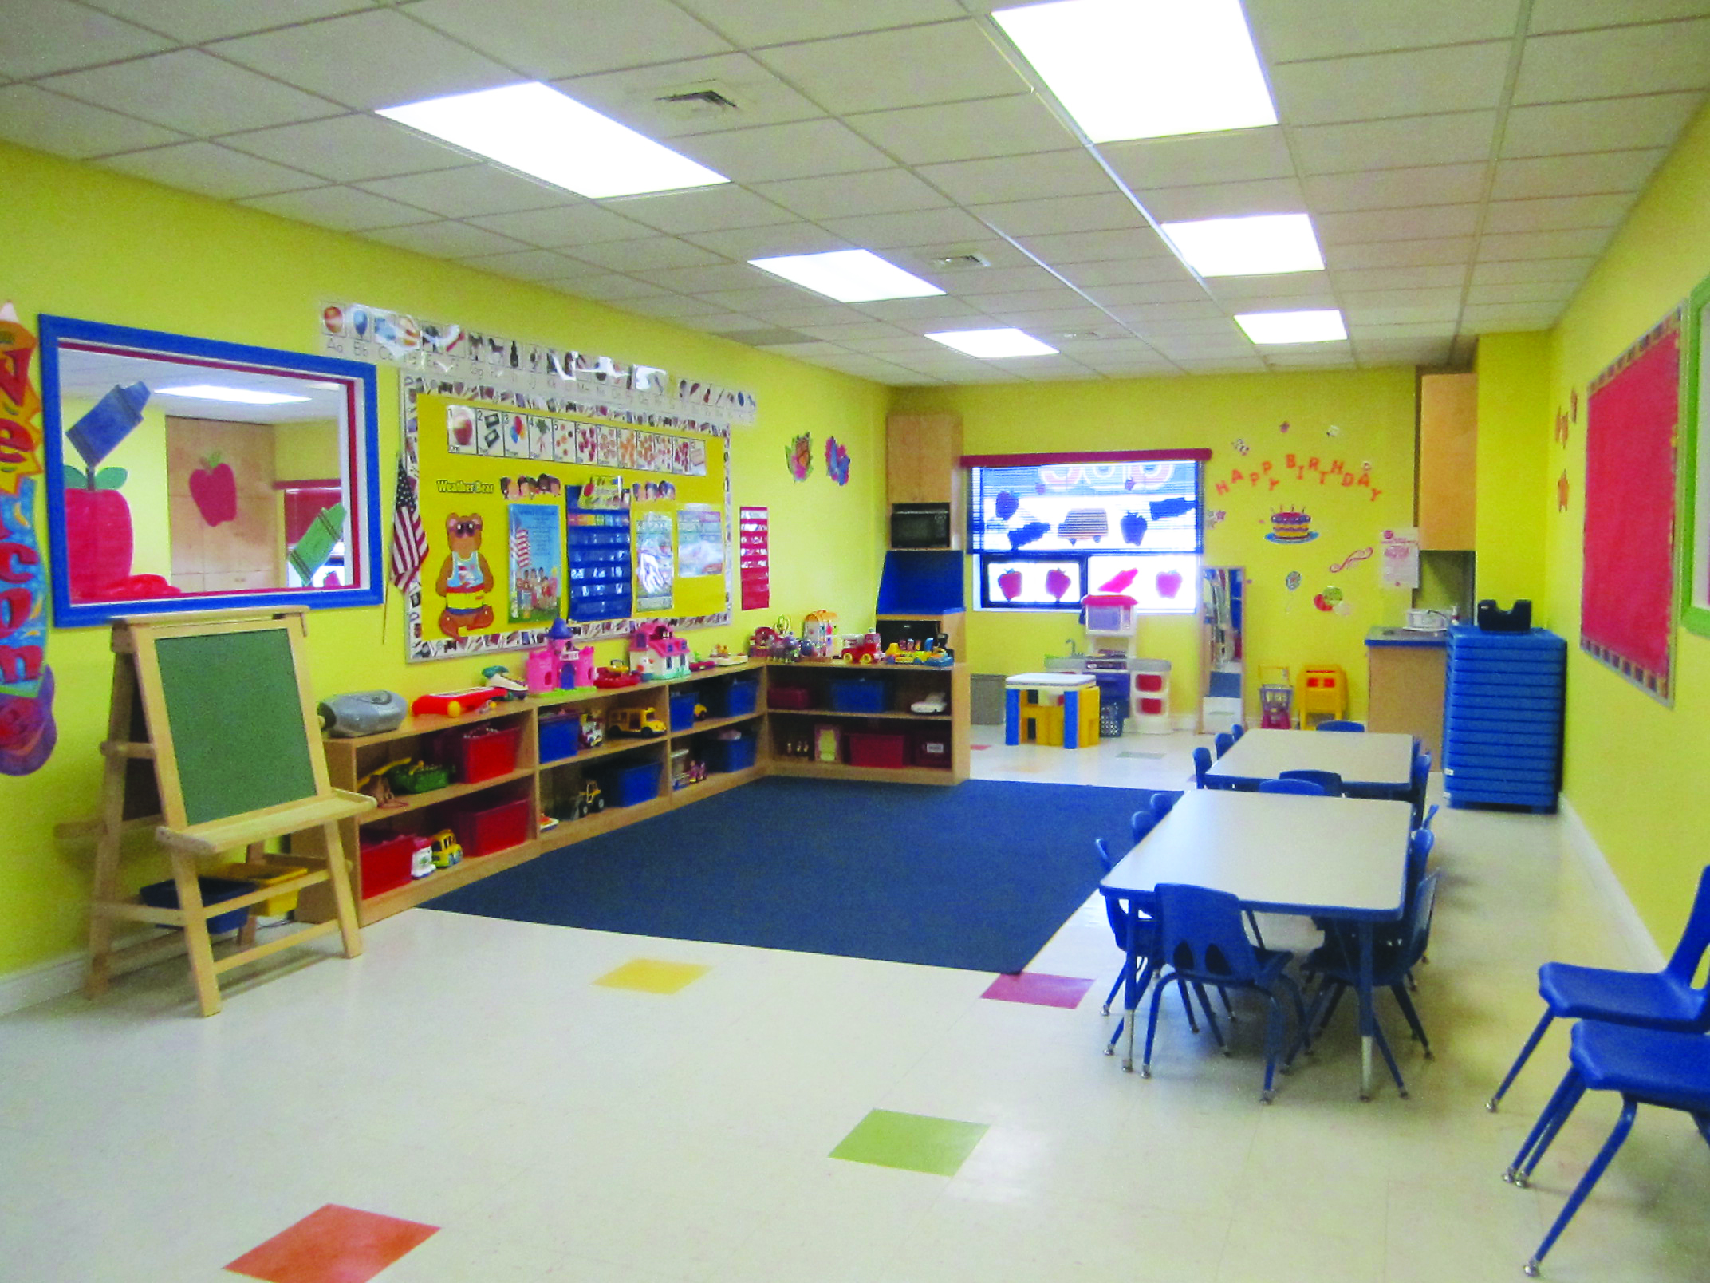

♥ Warm, caring atmosphere

♥ Children who are happily involved

♥ A clean, safe environment

♥ Variety of toys and learning materials

♥ Open door policy

♥ Nutritious meals

For more information about registering, availability, and to schedule a visit please feel free to call between 10am to 4pm.

Contact Person: Matthew Green

Telephone: (123) 456 7899

Email: info@hloom.com

You may also visit us at www.hloom.com

**We are a licensed and registered!**

**Copyright information - Please read**

© This [**Free Flyer Template**](http://www.hloom.com/flyers/) is the copyright of Hloom.com. You can download and modify this template for your own personal use to create a flyer for yourself, or for someone else. You can (and should!) [remove this copyright notice](http://www.hloom.com/resumes/how-to-format-word/) before customizing your flyer.

You may not distribute or resell this template, or its derivatives, and you may not make it available on other websites without our prior permission. All sharing of this template must be done using a link to <http://www.hloom.com/flyers/>.

For any questions relating to the use of this template please email us - [info@hloom.com](mailto:info@hloom.com)