[](https://www.myperfectresume.com/membership/RegisterGuestUser.aspx?wizard=true&productid=17&utm_source=hloom-com&utm_medium=referral&utm_campaign=word-template)  
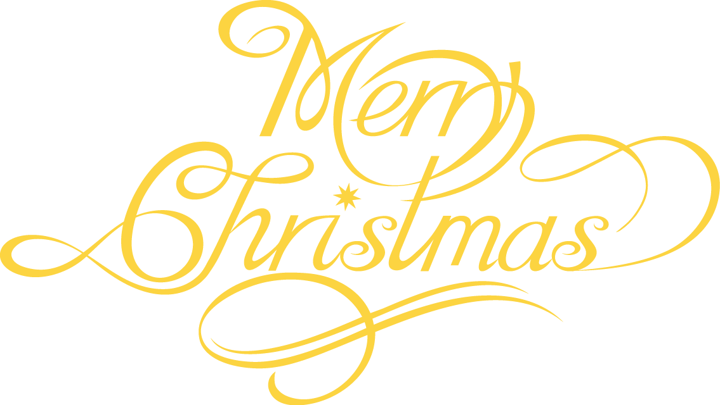

Swiss Restaurant and Night Club

**JOIN US THIS HOLIDAY SEASON**

Saturday December 24th

Dinner Service 5pm and dancing ‘till dawn!

Don’t miss out on a fabulous evening full of dinning, dance, and fun!

Call now for reservations

123-456-7899

**Copyright information - Please read**

© This [**Free Invitation Template**](http://www.hloom.com/invitations/) is the copyright of Hloom.com. You can download and modify this template for your own personal use to create an invitation for yourself, or for someone else. You can (and should!) [remove this copyright notice](http://www.hloom.com/resumes/how-to-format-word/) before customizing your invitation.

You may not distribute or resell this template, or its derivatives, and you may not make it available on other websites without our prior permission. All sharing of this template must be done using a link to <http://www.hloom.com/invitations/>.

For any questions relating to the use of this template please email us - [info@hloom.com](mailto:info@hloom.com)