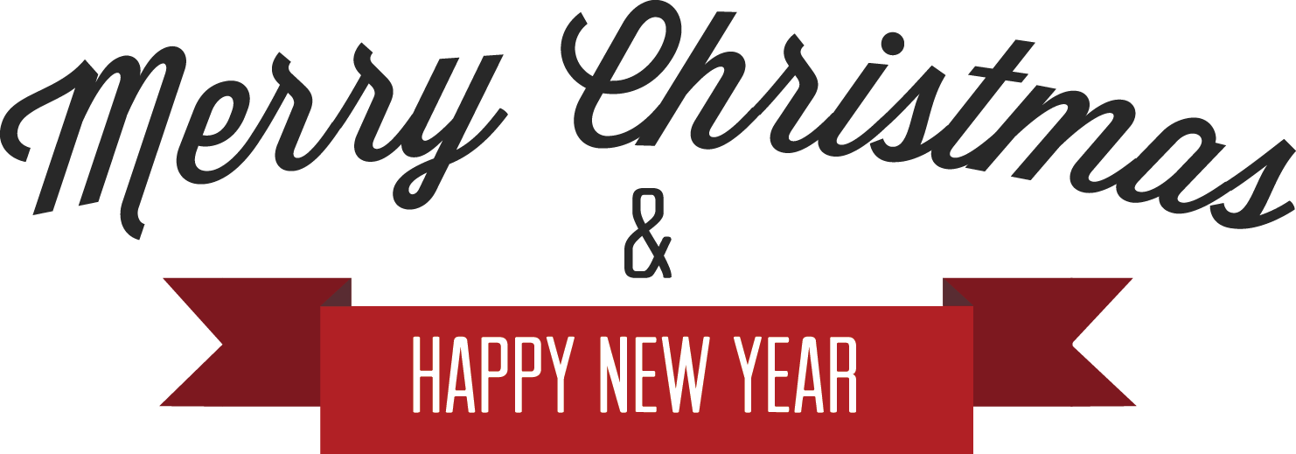

You have been cordially invited
to join us for a delightful time to enjoy good food, good wine, and good company

Friday, 22nd December 2013  12 noon onwards  Smart Casual  RSVP by 14th December 2013 |  | 123 Main Street  Chicago, Il 606897  Tel: (123) 456 78 99  www.hloom.com

Copyright information - Please read

© This Free Flyer Template is the copyright of Hloom.com. You can download and modify this template for your own personal use to create a flyer for yourself, or for someone else. You can (and should!) remove this copyright notice before customizing your flyer.

You may not distribute or resell this template, or its derivatives, and you may not make it available on other websites without our prior permission. All sharing of this template must be done using a link to http://www.hloom.com/flyers/.

For any questions relating to the use of this template please email us - info@hloom.com

