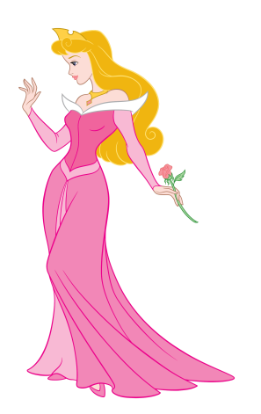
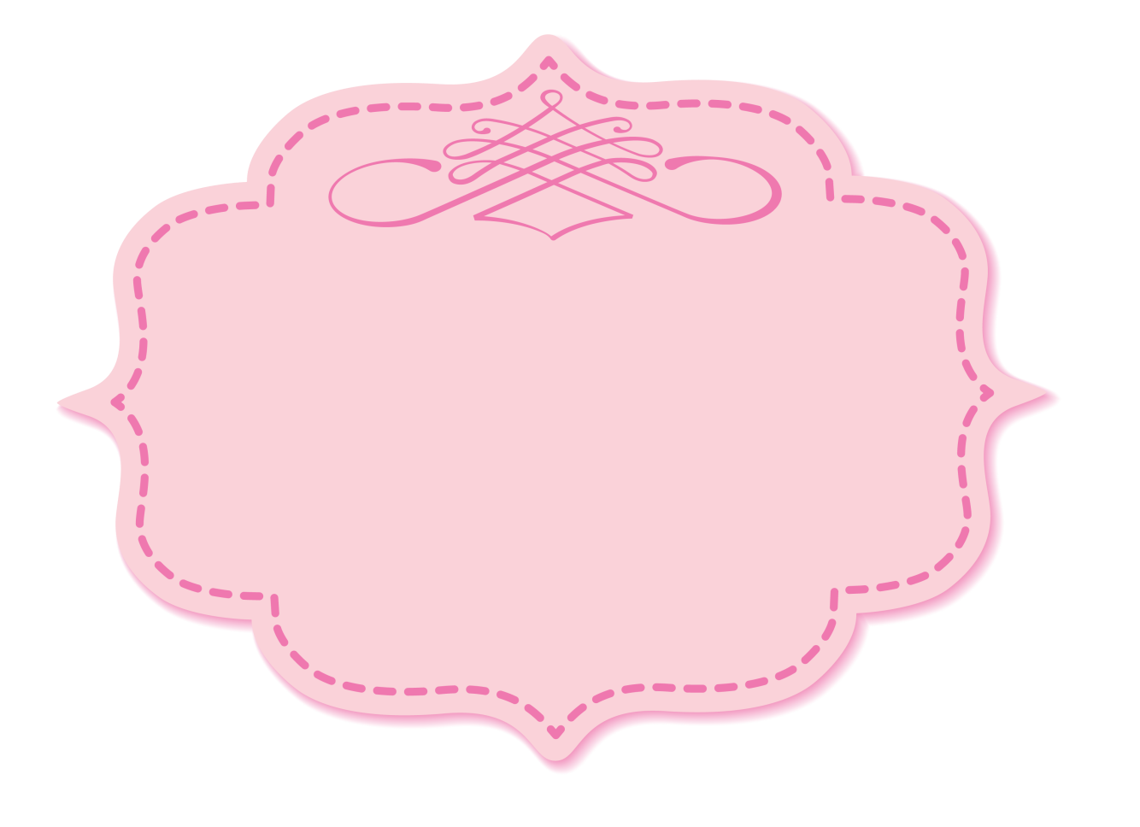
Put on your favourite princess dress to celebrate
Ann’s 4th birthday
Saturday, May 3rd 2013
4423 Sheridan Street Chicago
RSVP to Mother Queen
(123) 456 78 99
Princess Party

Copyright information - Please read

© This Free Invitation Template is the copyright of Hloom.com. You can download and modify this template for your own personal use to create an invitation for yourself, or for someone else. You can (and should!) remove this copyright notice before customizing your invitation.

You may not distribute or resell this template, or its derivatives, and you may not make it available on other websites without our prior permission. All sharing of this template must be done using a link to http://www.hloom.com/invitations/.

For any questions relating to the use of this template please email us - info@hloom.com

