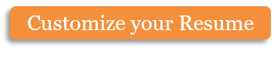  Name  phone  e-mail | Name  phone  e-mail | Name  phone  e-mail | Name  phone  e-mail | Name  phone  e-mail | Name  phone  e-mail | Name  phone  e-mail | Name  phone  e-mail
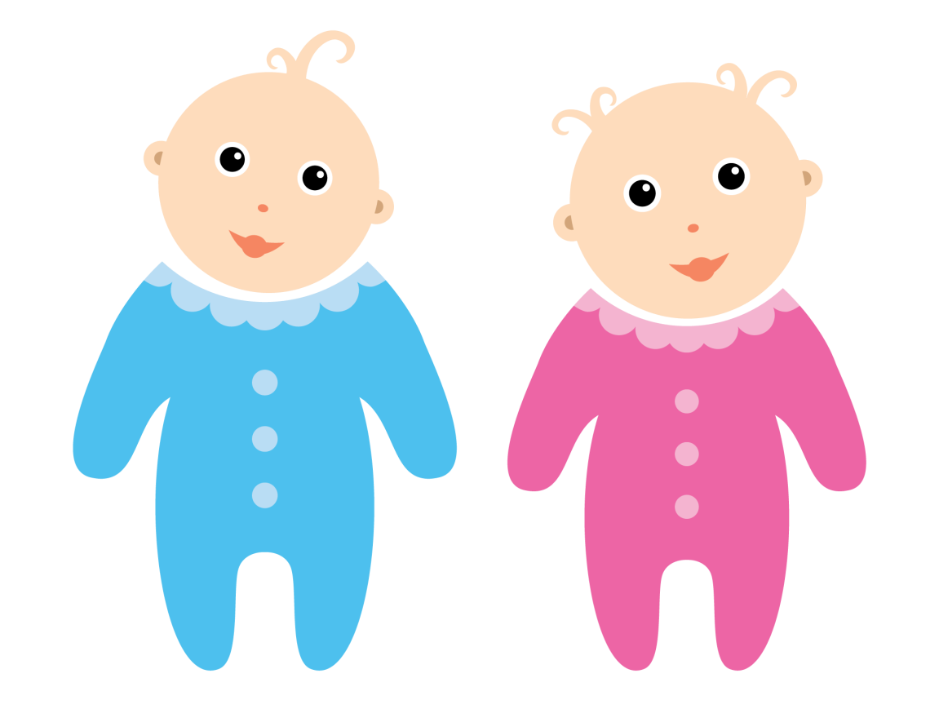

Need a babysitter?
My name is <Name>, I am XX years old. I am very good with children and will give 100% of my attention to your kids. I am trustworthy, reliable, loyal, responsible, and a great, loving person. I can do simple housework (cleaning, dog walking, some cooking) when children are asleep. I am looking for work in <Neighborhood>.
I am available:
X:XX pm – X:XX pm (Mon-Fri)
X:XX am – X:XX pm (Sat & Sun)
Charge: $XX an hour

Copyright information - Please read

© This Free Flyer Template is the copyright of Hloom.com. You can download and modify this template for your own personal use to create a flyer for yourself, or for someone else. You can (and should!) remove this copyright notice before customizing your flyer.

You may not distribute or resell this template, or its derivatives, and you may not make it available on other websites without our prior permission. All sharing of this template must be done using a link to http://www.hloom.com/flyers/.

For any questions relating to the use of this template please email us - info@hloom.com

