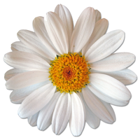

Sale!

Sale!

Sale!

Don’t Miss Out on Your Chance to SAVE!
All decorative glassware
20% off!
Pots and baskets
25% off!
Assorted garden tools
starting at $10!
The Lovely House
567 Main Street
Clearfield, PA 98052
(253) 555-0148

Store Hours:
10:00 A.M. – 5:00 P.M. (Mon. thru Fri.)
9:00 A.M. – 6:00 P.M. (Sat. & Sun.)
Sale prices good through 11/17/04

Copyright information - Please read

© This Free Flyer Template is the copyright of Hloom.com. You can download and modify this template for your own personal use to create a flyer for yourself, or for someone else. You can (and should!) remove this copyright notice before customizing your flyer.

You may not distribute or resell this template, or its derivatives, and you may not make it available on other websites without our prior permission. All sharing of this template must be done using a link to http://www.hloom.com/flyers/.

For any questions relating to the use of this template please email us - info@hloom.com

