


LET'S NOT FORGET OUR ROOTS

More than 100 years passed since these trees were planted. Came to see 100 years
of pure history. More than 100 years passed since these trees were planted. Came to
see 100 years of pure history. More than 100 years passed since these trees were planted.
Came to see 100 years of pure history. More than 100 years passed since these trees were
planted. Came to see 100 years of pure history. More than 100 years passed since these trees
were planted. Came to see 100 years of pure history.

Holiday Programme

June : from 1st to 15th - from 16th to 30th

July : from 2nd to 16th - from 17th to 31st
August : from 2nd to 16th - from 17th to 31st
September : from 1st to 15th - from 16th to 30th

Camping park and reservations +505.123.456.789
State : Near Us
City : Our City
Address: there came the address

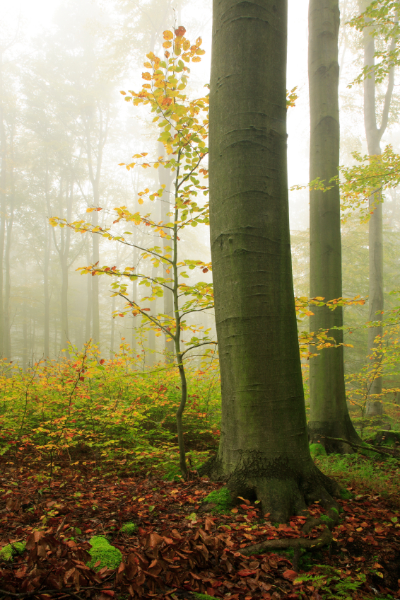
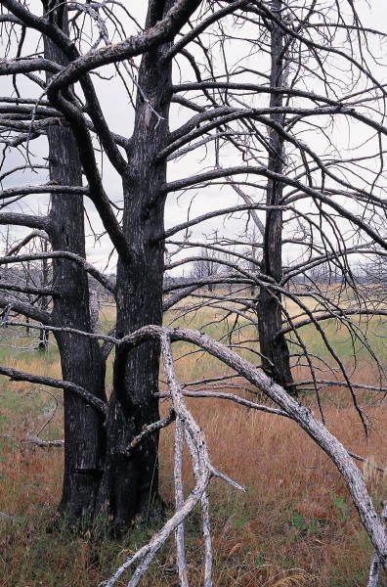
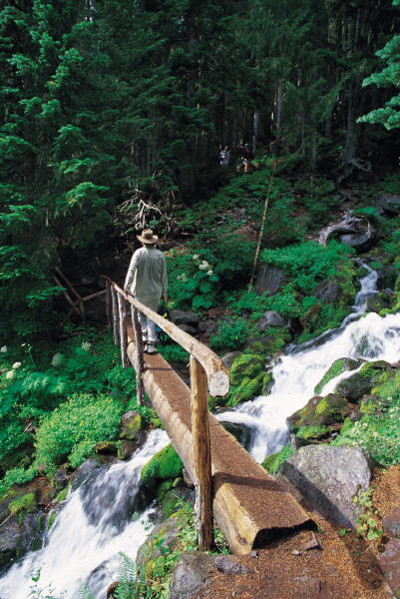
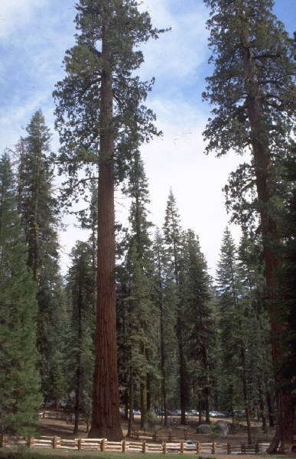
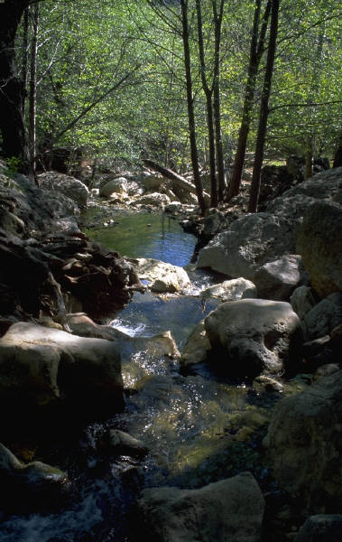
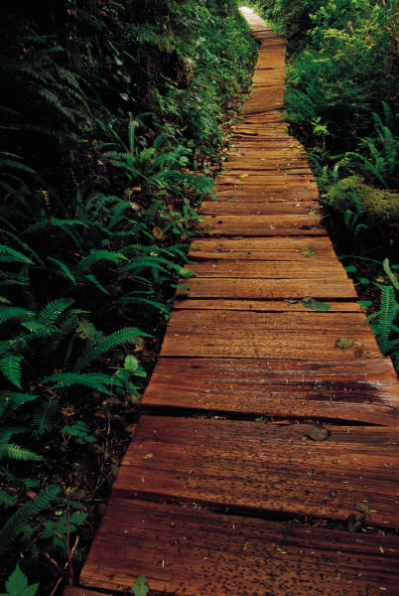
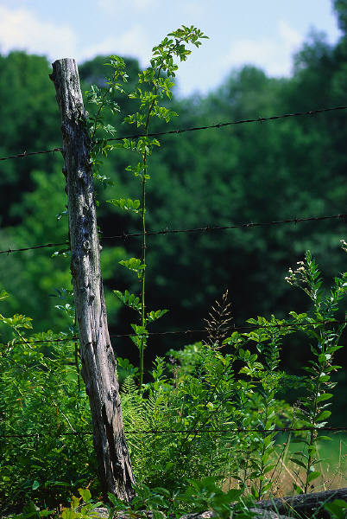

Copyright information - Please read

© This Free Flyer Template is the copyright of Hloom.com. You can download and modify this template for your own personal use to create a flyer for yourself, or for someone else. You can (and should!) remove this copyright notice before customizing your flyer.

You may not distribute or resell this template, or its derivatives, and you may not make it available on other websites without our prior permission. All sharing of this template must be done using a link to http://www.hloom.com/flyers/.

For any questions relating to the use of this template please email us - info@hloom.com

