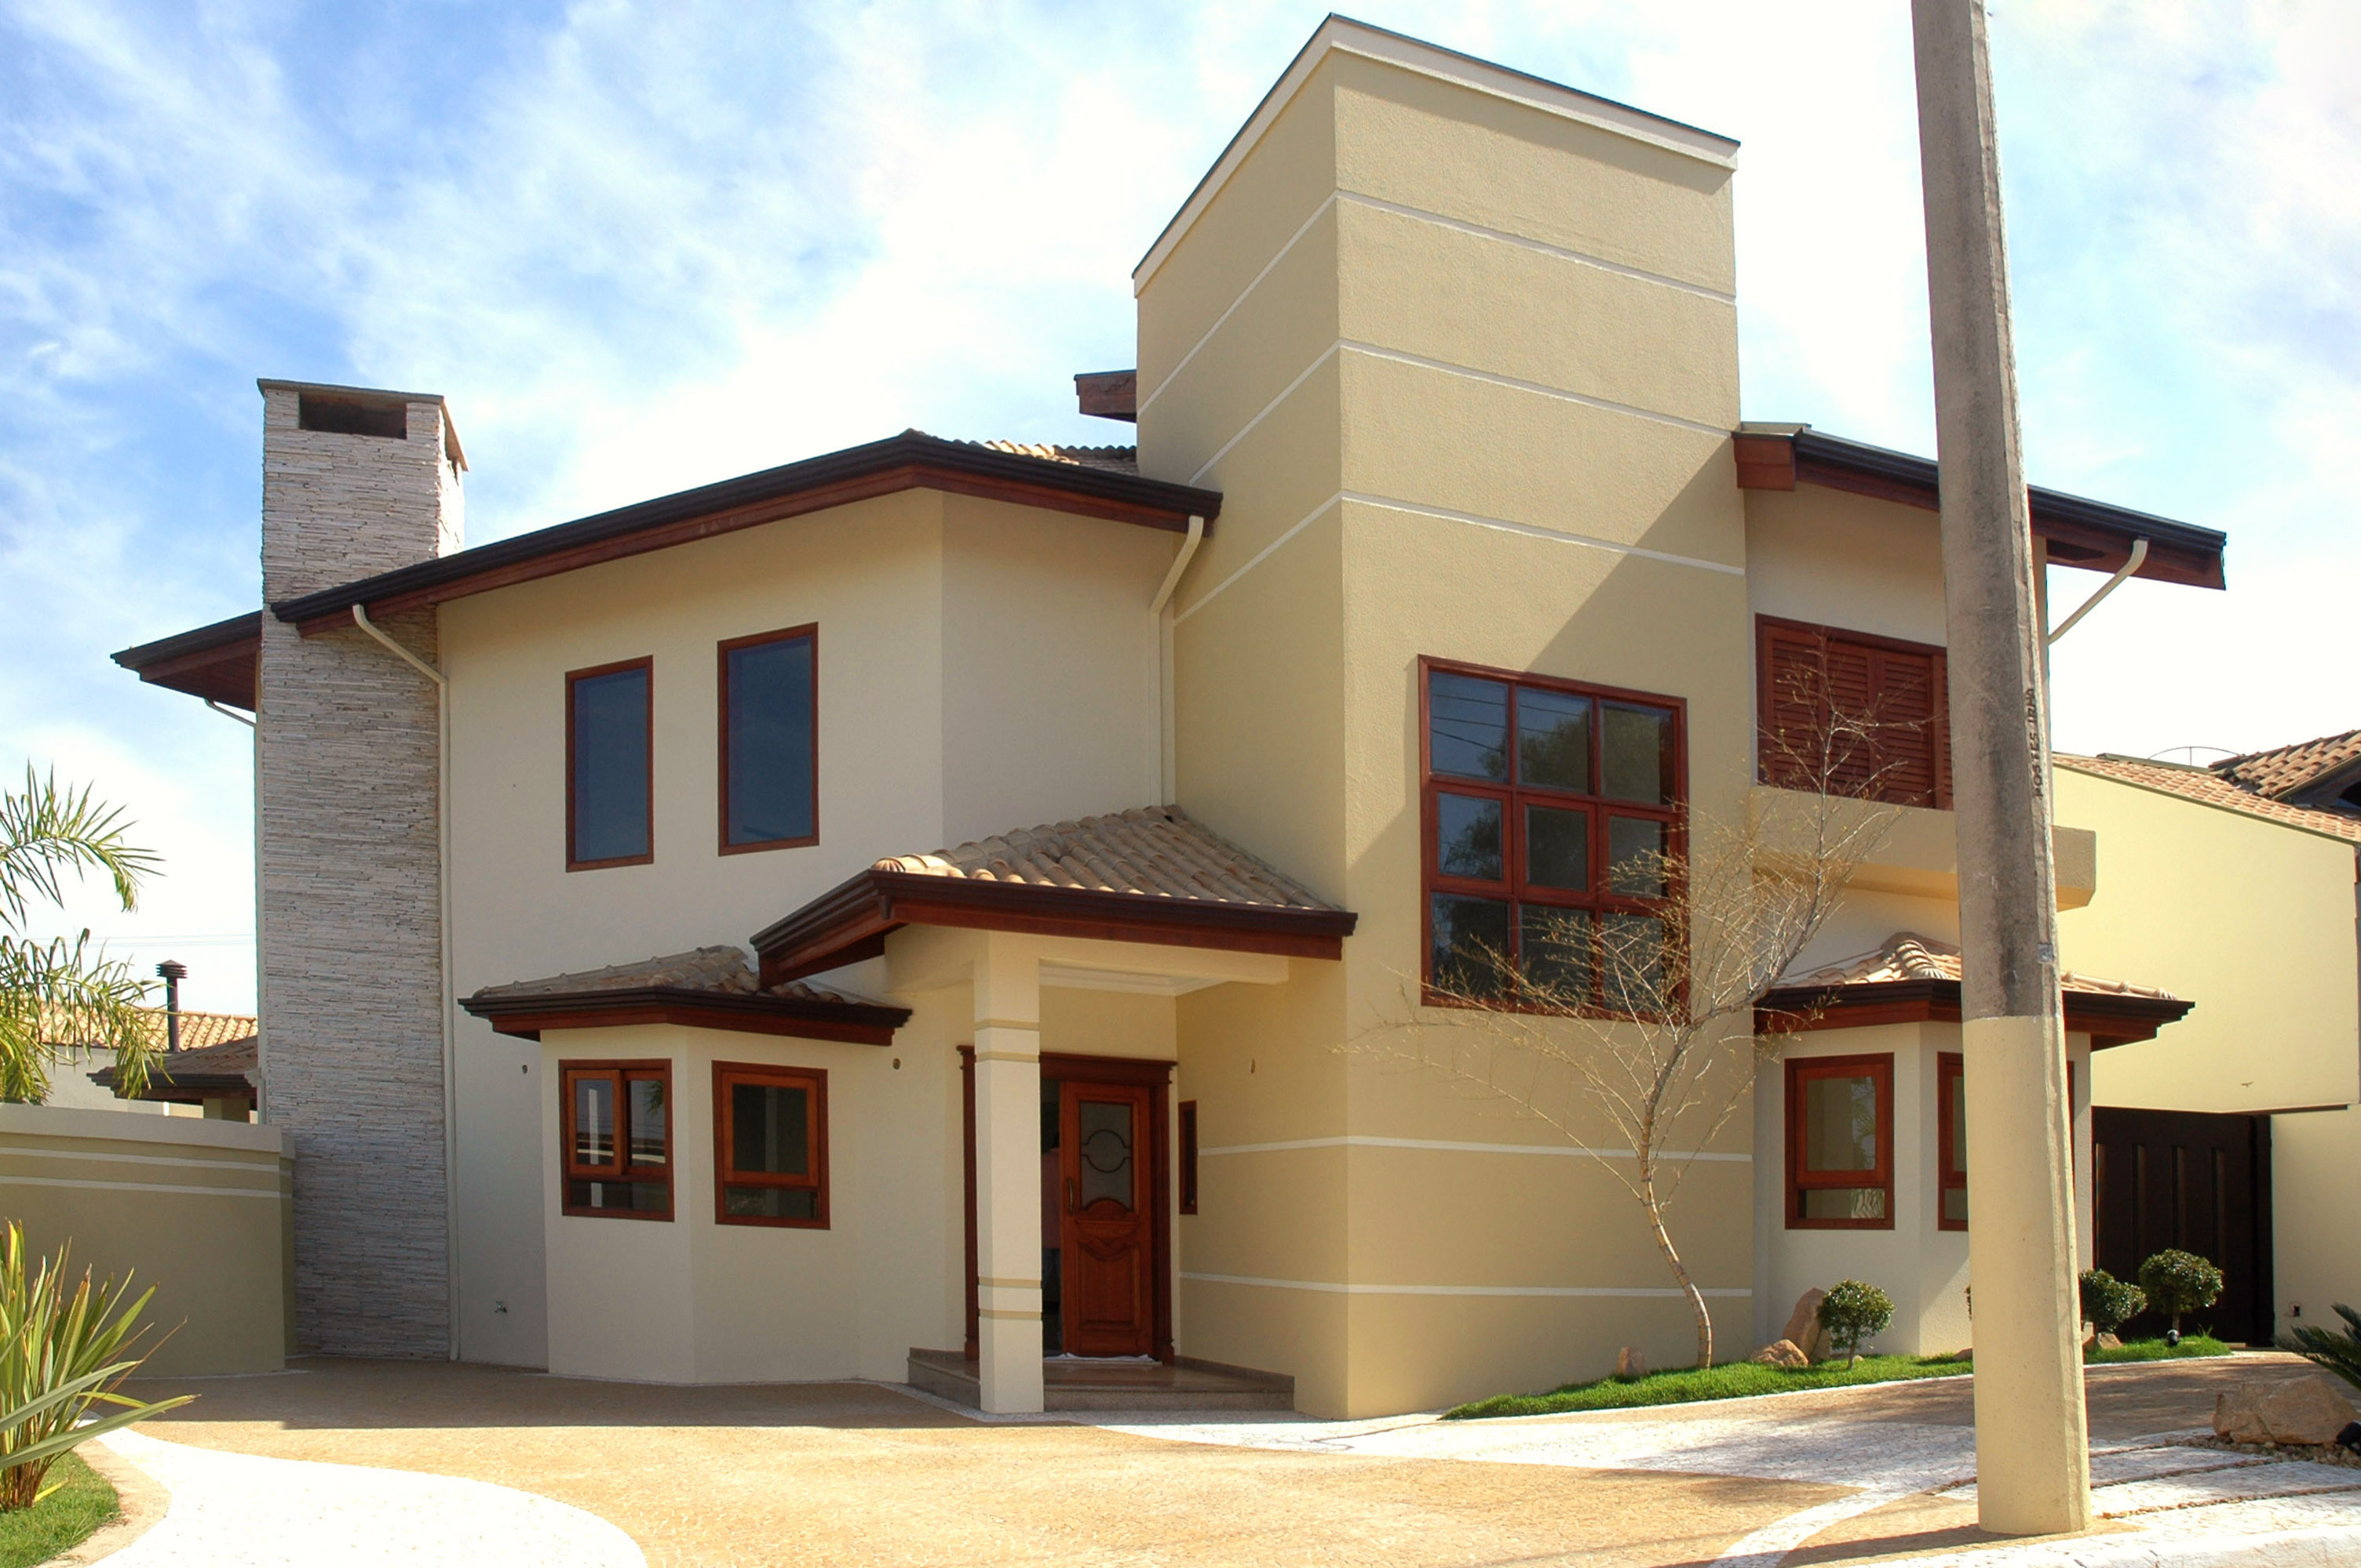


For a personal showing, please call
800-555-1212
or experience
a virtual tour
on our website: www.yourwebsite.com
Fabulous space, great location, you must see it to really appreciate the ambiance and setting. Designed for family living with dramatic open areas and plenty of windows and light. Lushly landscaped with Koi pond and perennial gardens. Only 20 minutes from city center and two blocks from Kennedy Elementary School.

- 3200 square feet, 4 bedrooms, 3.5 bathrooms
- Large, finished basement, perfect for family activities
- Hardwood floors with mahogany inlay
- Custom gourmet kitchen with Sub-Zero refrigerator & double ovens
- Formal dining area, custom designed home office space
$428,000

Agent Name
(000) 555-1212 direct
(000) 555-1212 cell
email@youremail.com
www.yourwebsite.com
Your Dream Home

Copyright information - Please read

© This Free Flyer Template is the copyright of Hloom.com. You can download and modify this template for your own personal use to create a flyer for yourself, or for someone else. You can (and should!) remove this copyright notice before customizing your flyer.

You may not distribute or resell this template, or its derivatives, and you may not make it available on other websites without our prior permission. All sharing of this template must be done using a link to http://www.hloom.com/flyers/.

For any questions relating to the use of this template please email us - info@hloom.com

